 



Virtual reality system for tourism

**Graduation Project Report**

**Supervised by: Dr.Reda Abdelwhab**



Content:

1-introduction ……………………………..………………..……3

2-problem statement …………………………………………......4

3-Architecture & Algorithm ……………………………………..5

4-objctive …………………………………….…………….…….7

5-work plan ………………………………………………….…...7

6-current state ……………………………………………………8

7-future work ………………………………………………….....8

8-refrences …………………………………………………….....9

**1-Introduction:**

Ancient Egypt is arguably the world's most favorite

and famous 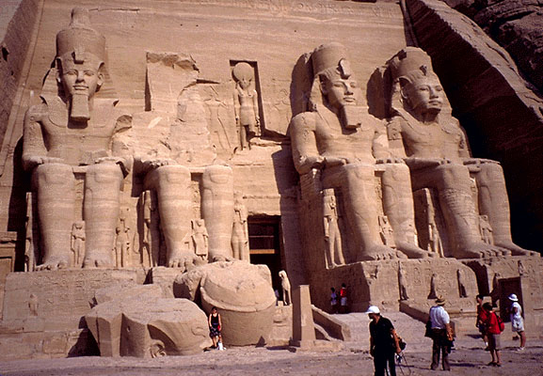ancient civilization, people from all over the world interested in studying the history of ancient Egypt

and tourists from all over countries come to visit Egypt to see the Egyptian arts and ancient monuments.

The main importance of this civilization is that it introduced civilization to the world, they also introduced social classes, agrarian societies and monuments.

The civilization of Ancient Egypt left many monuments and temples that have become attractions for modern-day visitors to Egypt.

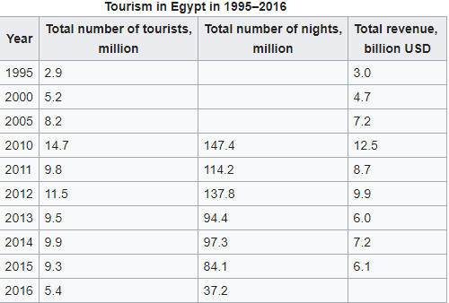

**Tourism** is one of the leading sources of income, crucial to Egypt's economy. At its peak in 2010 the sector employed about 12% of Egypt's workforce serving approximately 14.7 million visitors Egypt, and providing revenues of nearly $12.5 billion. As well as contributing more than 11% of GDP and 14.4% of foreign currency revenues.

For the importance of tourism and the importance of the ancient Egypt civilization, computer scientists and software engineers should take care of this part in their projects and give this field some effort to help our country and raise our history or even the history of mankind

And for all of this comes the importance of our application and system to help people to know about this great civilization and learn about its history.

**2-Problem Statement:**

Due to the huge amount of monuments and sculptures and statues that the ancient Egypt civilization left and due to the big number of the pharaohs it become harder to save or learn names of all this pharaohs or even classify a new one if we discovered.

We notice a steep rise in the use of computer vision and image recognition through deep learning, as well as a growing use of this technology in business applications. One area which has been grabbing headlines is driverless cars, which rely heavily on deep-learning and new image capture techniques to “see” and learn about their surroundings.

As these technologies become more powerful, it’s not just businesses and researchers who are able to tap into them: many are already concerned about the many potential misuses, such as deep fake videos and video face recognition…

So our system designed to recognize faces of ancient Egypt sculptures using the progress of computer vision techniques and deep learning algorithms

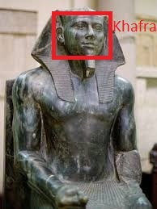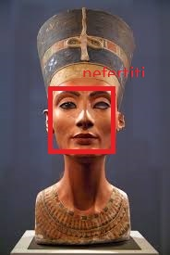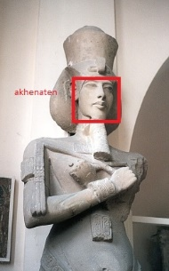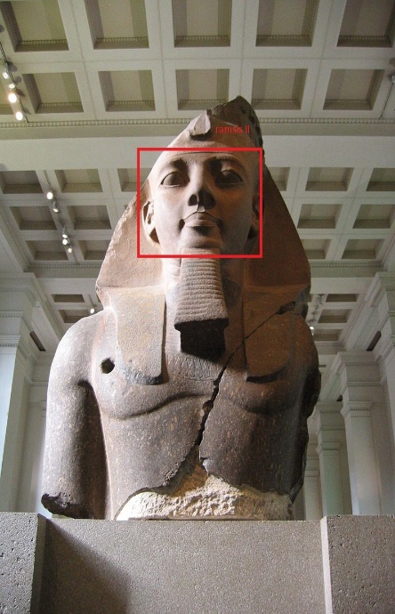

**3- Architecture & Algorithm:**

By applying computer vision techniques we can detect and recognize and classify the faces of humans and detecting objects and we will use this techniques in our system.

There are many techniques and algorithms for facial detection and recognition but the main steps or concepts for them is

1. Data Gathering: Gather face data (face images in this case) of the persons you want to identify.
2. Train the Recognizer: Feed that face data and respective names of each face to the recognizer so that it can learn.
3. Recognition: Feed new faces of that people and see if the face recognizer you just trained recognizes them.

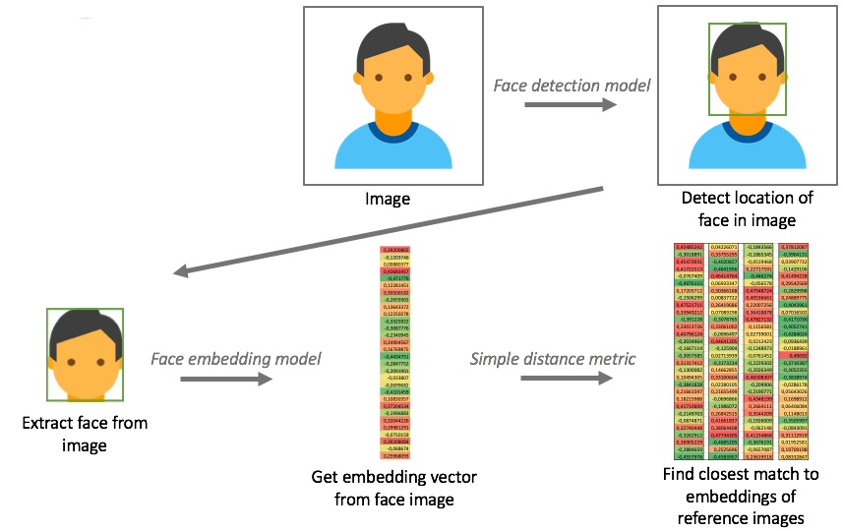

So our system main structure:

Train data

System Process

Face detection

System Process

Test new image

System Process

Establish mask

Estimate Weight

Images

Image

Feature extraction

Estimate Weight

Mismatch

Estimate Weight

Get data

Estimate Weight

Match

Estimate Weight

Classification

Estimate Weight

System Features

OpenCV provides us with two pre-trained and ready to be used for face detection classifiers:

1. Haar Classifier
2. LBP Classifier

And this a comparison between them:

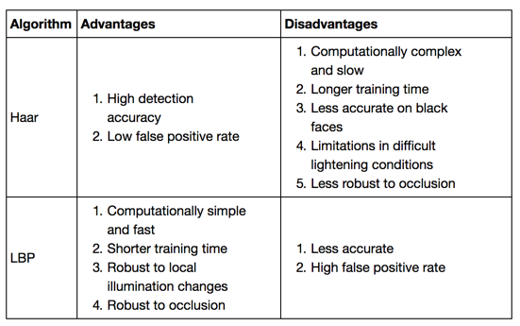

There are many facial feature extraction and classification algorithms:

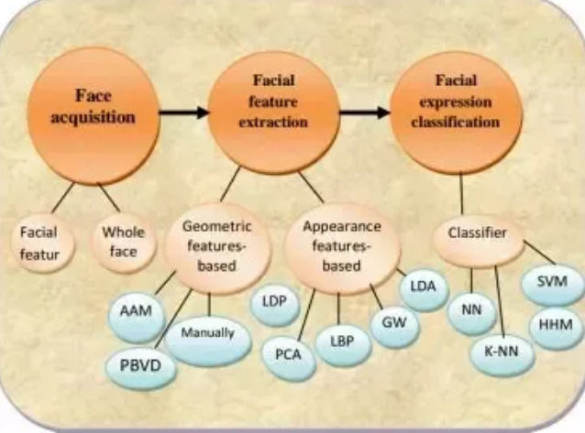

As start we will use OpenCV Library with PYTHON

Using the LBP (Local Binary Patterns) cascade classifier to detect faces and THE LBPH (Local Binary Patterns Histograms) face recognizer to implement the main structure of the system.

**4-Objective:**

Purpose: Our system designed to recognize faces of ancient Egypt sculptures specially the sculptures of pharaohs so that any tourist can use his camera to identify and know the name of this pharaoh and get a brief history for this him.

Mission: build computer vision app

Vision: help tourists.

**5-Initial Project Plan:**

1. **Prepare Training Data:**Read training images for each subject along with their labels,
2. **Detect faces:** from each image and assign each detected face an integer label of the person it belongs.
3. **Train Face Recognizer:** Train OpenCV's LBPH recognizer by feeding it the data we prepared in step 2.
4. **Prediction:** Introduce some test images to face recognizer and see if it predicts them correctly.

**6-current state:**

1-gather some training data

2-impement the main structure of the system using python and openCV library.

3-get some result and try to improve

4-prepare for using the deep learning algorithms.

**7-Future work:**

1-train more data or use pretrained neural network or One-shot Image Recognition.

2-use deep metric learning to improve the performance of the software.

3-try to implement it as mobile application.

**8-References:**

*[1]* ***Matt Smith (11 September 2014). "Egypt tourist numbers to rise 5–10 pct in 2014 – minister". Reuters. Retrieved 9 October 2014.***

*[2] Toby Wilkinson* ***"****The Rise and fall of Ancient Egypt Paperback****"*** *January 8, 2013.*

*[3]* ***Kenneth Dawson-Howe "A Practical Introduction to Computer Vision with OpenCV" (Wiley-IS&T Series in Imaging Science and Technology) 1st Edition, Kindle Edition.***

*[4]* *https://docs.opencv.org/2.4/modules/contrib/doc/facerec/facerec_tutorial.html.*

*[5]* *https://www.superdatascience.com/opencv-face-detection/.*

*[6] https://www.pyimagesearch.com/2018/04/09/how-to-quickly-build-a-deep-learning-image-dataset/.*

*[7]* *https://medium.com/data-science-101/face-recognition-opencv-e841dc0006c6.*